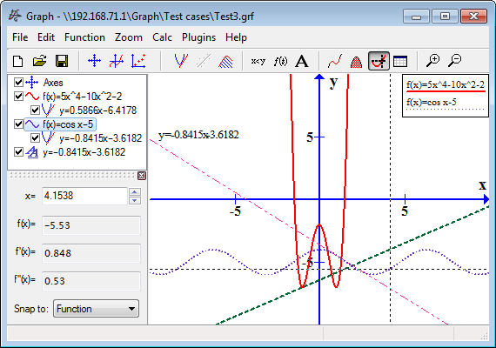

Model synchronization using Guard functions.

Performability SRN model

Dependability SRN model

Model annotation phase

Performance SRN model

**Deployment Phase**

UML collaboration & diagram

Model Validator



Model Validator

Model Transformation phase

Phase for state machine generation

